繪本融入英語課程教案設計
科目/領域別： 英語文 設計者：E組 潘思存(博愛) 賴嫆臻(僑平)
學習階段： 第 1學習階段(國小 三 年級) 教學年級：三 年級 ( 第二 學期)
單元名稱： Pink is for everyone
教學資源/設備需求： PPT, post-it, storybook of “Pink is for Boys”, worksheet

總節數： 2 節

核心素養、學習重點（含學習表現與學習內容）、學習目標對應情形
核心  素  養 | 總綱 | B1 符號運用與溝通表達  C2 人際關係與團隊合作
核心  素  養 | 英語文課綱 | 英-E-A2  英-E-B1  英-E-C2
學習  重點 | 學習表現 | ◎ 2-Ⅱ-3 能說出課堂中所學的字詞。  ◎ 2-Ⅱ-4 能使用簡易的教室用語。  ◎ 2-Ⅱ-5 能使用簡易的日常生活用語。  ◎ 2-Ⅱ-6 能以正確的發音及適切的語調說出簡易句型的句子。  ◎ 3-Ⅱ-2 能辨識課堂中所學的字詞。  ◎ 3-Ⅱ-3 能看懂課堂中所學的句子。  ◎5-Ⅱ-3 能以正確的發音及適切的速度朗讀簡易句型的句子。  ◎ 5-Ⅱ-4 能運用所學的字母拼讀規則讀出英文字詞。
學習  重點 | 學習內容 | A. 語言知識  ◎ Ac-Ⅱ-1 簡易的教室用語。  ◎ Ac-Ⅱ-2 簡易的生活用語。  ◎ Ac-Ⅱ-3 第二學習階段  B. 溝通功能  B-Ⅱ-1 第二學習階段所學字詞及句型的生活溝通。
議題融入 |  | 議題名稱: 性別平等  學習主題: 性E7 解讀各種媒體所傳遞的性別刻板印象。  實質內涵: 性別平等 科技、資訊與媒體的性別識讀。
與其他領域/科目的連結
學習目標 |  | - 學生能發現生活及媒體中對顏色的性別刻板印象。  - 學生能熟練顏色相關的生字。  - 學生能熟練句型_____ is for boys and girls.  - 學生能了解顏色不該有性別之分，並尊重他人喜愛的顏色。
單元教學活動 |  |  | 評量策略（評量方法、觀察學生外顯行為）
Warm up: Rainbow song  - Ss listen to the song and talk about the colors they know.  - Ss learn to sing the song.  Show & Tell  - Teacher asks Ss “What color is your _____? (pencil, schoolbag, jacket and etc.)  - Ss take out the things Teacher asks for and answer.  - Teacher asks Ss to check the things they have taken out to see if there is a certain color they like.  Post-it  Teacher writes down two questions on the blackboard.  Q1: What is the color for boys?  Q2: What is the color for girls?  Each student takes two pieces of post-it paper. One is for the first question and another is for the second one. After Ss finish writing, they paste them on the blackboard according to the color they write. Ss can see if they have a stereotype for the colors.  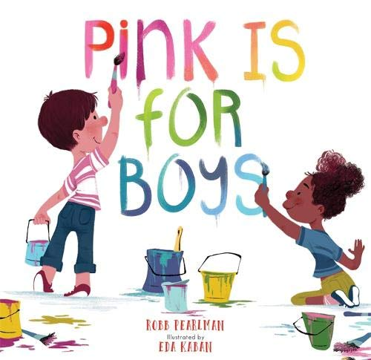  Storytime: Pink is for Boys  https://www.youtube.com/watch?v=kqyySFCXyHg  - Ss listen to the story.  - Ss retell the story to the teacher.  - Teacher asks Ss opinions about the story.  The End of the 1st Period  Wrap-up: Worksheet  Write down the most impressive part of the story (which color)  Warm up: Worksheet presentation- Pink is for Boys  - Ss show their worksheets of “Pink is for Boys” and read out loud the sentences they’ve written.  BLUE VS. PINK  Discuss the stereotype of color blue and pink around us  - Ss discuss about the use of blue and pink as boys and girls in the environment and write or draw them down on the whiteboard.  - Group-presentation  When did pink become a “Girl” Color?  https://www.youtube.com/watch?v=W3l_ufgxLJo  Pink Mask  Talk about the news and Ss share their ideas and feelings of seeing this news.  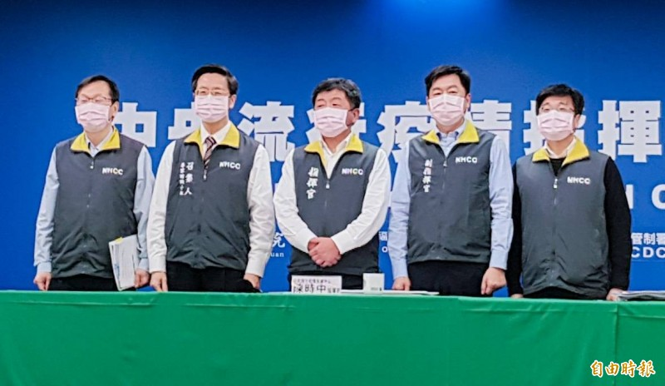  https://www.youtube.com/watch?v=glRbjULMTx8  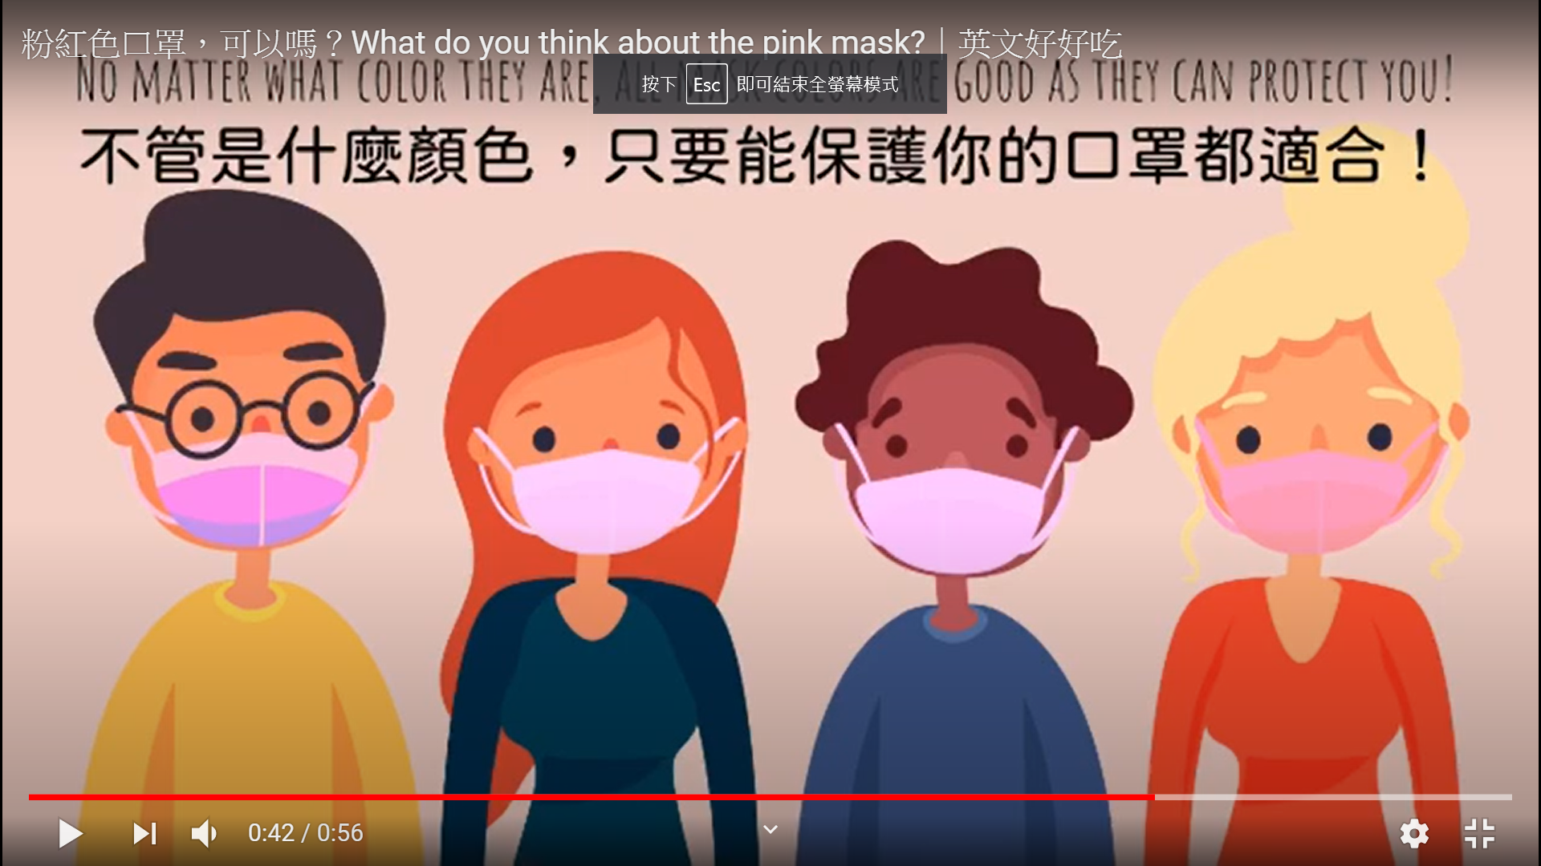  Group Discussion  - What would you say or do if somebody laugh at you just because of the color you like or wear?  - If others laugh at your friends just because of the color they like or wear, what would you do or say to them?  The End of the Second Period |  |  | 學生能提出曾學過的顏色  學生能專心歌唱  學生能拿出對應的物品並回答顏色  學生能觀察同儕與自己所使用的顏色  學生能寫出顏色，並依照顏色分類貼在黑板上  學生能專心聽故事  學生能發表自己對書中的意見及看法  學生能完成學習單  學生能念出自己寫的句子  學生能和同儕討論生活中使用刻板顏色的地方  學生能上台報告  學生能專心看影片  學生能看發表對此新聞的看法  學生能發表自己的意見
參考資料：
Storytime: Pink is for Boys
https://www.youtube.com/watch?v=kqyySFCXyHg

When did pink become a “Girl” Color?
https://www.youtube.com/watch?v=W3l_ufgxLJo

What do you think about the pink mask?(時中部長)
https://www.youtube.com/watch?v=glRbjULMTx8

附錄： (學習單、評量表格…)請參閱附件。

Class:______ Number:_______ Name:_________

____________ is for boys and girls and _______________________________.

All the colors are for EVERYONE, girls and boys.

